4 Slot Coin Operated Cola Vending Machine

Vending machines have long served as an automated dispensing machines that can dispense products on accepting money. Vending machines look simple but have a well designed mechanism behind the scenes that makes vending look so easy.
We here study this mechanism by developing a coin operated cola vending machine with 4 slots. This machine can dispense 4 different types of cola cans which are of different value.
The system makes use of 4 motors, spring coils, a coin detector, lcd display, controller circuitry along with the machine frame to develop a vending machine. The machine will be capable of providing user the choice of selecting the cola, asking for respective price and dispensing the product on detecting the money.
The system consists of 4 slots each having a spring coil specially designed to fit cola cans. Each coil is connected to a motor that is used to rotate the coil on respective product demand.
The machine owner can feed the cola cans into the system by entering a password. Only on entering right password, the owner can open the machine. Once all products are added into the trays the machine is ready for operation.
Once the user approaches the machine he/she can see a list of cola options displayed on the mini LCD display. The user can use the keypad to select the cola needed. On selection the system displays the price of the chosen cola.
The user now needs to insert respective coins in the machine as per the amount mentioned. On inserting wrong coins the system returns them. On detecting right amount paid, the system now accepts the payment.
The controller now operates the motor of the respective cola slot to drop the can. Rotating the motor of respective slot, the coil motion pushes the cans outwards until the outermost can falls into the user bin. There we mount an openable door that can only allow user to collect can fallen in the tray and not reach out to other cans in the machine.
Thus we here study and design the mechanism of a vending machine.

Components
- DC Motors
- Spring Coils
- Coin Detector
- Collection tray
- Hinges and Door handle
- LCD Display
- Keypad and Buttons
- Controller Circuitry
- Mounts and Joints
- Base Frame
- Supporting Frame
- Nuts and Bolts
- Screws and Joints

Block Diagrams

Front View
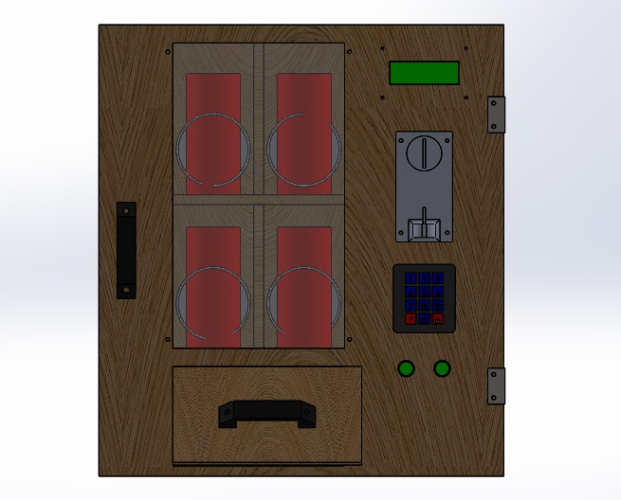
3D Views
